**ListofPlayers.js**

import React from "react";

const ListofPlayers = () => {

const players = [

{ name: "Virat", score: 95 },

{ name: "Rohit", score: 88 },

{ name: "Rahul", score: 65 },

{ name: "Dhoni", score: 72 },

{ name: "Pant", score: 60 },

{ name: "Jadeja", score: 77 },

{ name: "Ashwin", score: 50 },

{ name: "Bumrah", score: 48 },

{ name: "Shami", score: 80 },

{ name: "Kohli", score: 93 },

{ name: "Suryakumar", score: 55 },

];

const below70 = players.filter(player => player.score < 70);

return (

<div>

<h2>All Players</h2>

<ul>

{players.map((p, index) => (

<li key={index}>{p.name} - {p.score}</li>

))}

</ul>

<h2>Players with Score Below 70</h2>

<ul>

{below70.map((p, index) => (

<li key={index}>{p.name} - {p.score}</li>

))}

</ul>

</div>

);

}export default ListofPlayers;

**IndianPlayers.js**

import React from "react";

const IndianPlayers = () => {

const oddTeam = ["Rohit", "Rahul", "Pant", "Jadeja", "Bumrah"];

const evenTeam = ["Virat", "Dhoni", "Ashwin", "Shami", "Suryakumar"];

const [player1, player2, ...restOdd] = oddTeam;

const [even1, even2, ...restEven] = evenTeam;

const T20players = ["Kohli", "Rohit"];

const RanjiTrophy = ["Pujara", "Rahane"];

const allPlayers = [...T20players, ...RanjiTrophy];

return (

<div>

<h2>Odd Team</h2>

<p>Captain: {player1}</p>

<p>Vice Captain: {player2}</p>

<h2>Even Team</h2>

<p>Captain: {even1}</p>

<p>Vice Captain: {even2}</p>

<h2>Merged Players (T20 + Ranji)</h2>

<ul>

{allPlayers.map((p, index) => <li key={index}>{p}</li>)}

</ul>

</div>

);

};

export default IndianPlayers;

**App.js**

import React from "react";

import ListofPlayers from "./components/ListofPlayers";

import IndianPlayers from "./components/IndianPlayers";

function App() {

const flag = true; // Change to false to test other view

return (

<div className="App">

<h1>Cricket App</h1>

{flag ? <ListofPlayers /> : <IndianPlayers />}

</div>

);

}

export default App;

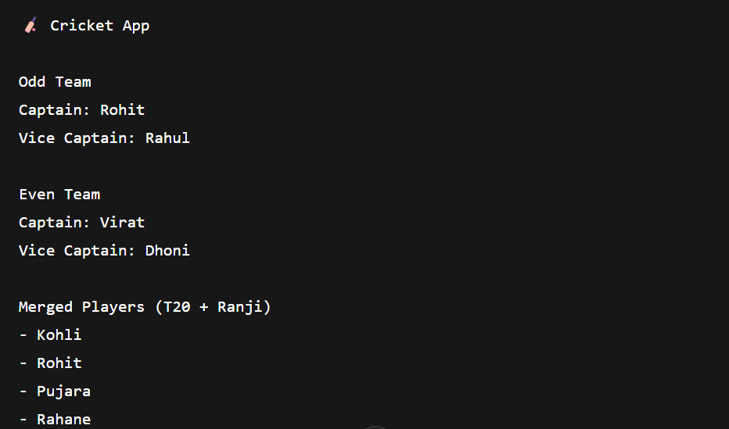

1. **React Lab: "Office Space Rental App"**

**App.js**

import React from "react";

function App() {

const heading = "Office Space Rentals";

const officeList = [

{

name: "Sky Tower",

rent: 45000,

address: "123 Cloud Street, Mumbai",

image: "https://via.placeholder.com/300x150?text=Sky+Tower"

},

{

name: "Tech Hub",

rent: 75000,

address: "456 Innovation Lane, Bangalore",

image: "https://via.placeholder.com/300x150?text=Tech+Hub"

},

{

name: "EcoSpace",

rent: 60000,

address: "789 Greenway Blvd, Delhi",

image: "https://via.placeholder.com/300x150?text=EcoSpace"

}

];

return (

<div style={{ textAlign: "center", padding: "20px" }}>

<h1>{heading}</h1>

{officeList.map((office, index) => {

const rentStyle = {

color: office.rent < 60000 ? "red" : "green",

fontWeight: "bold"

};

return (

<div

key={index}

style={{

border: "1px solid #ccc",

borderRadius: "10px",

padding: "10px",

margin: "20px auto",

width: "320px"

}}

>

<img src={office.image} alt={office.name} style={{ width: "100%", borderRadius: "8px" }} />

<h2>{office.name}</h2>

<p style={rentStyle}>Rent: ₹{office.rent}</p>

<p>Address: {office.address}</p>

</div>

);

})}

</div>

);

}

export default App;

**2.Eventexamplesapp**

**App.js**

import React, { useState } from "react";

import CurrencyConvertor from "./CurrencyConvertor";

function App() {

const [count, setCount] = useState(0);

const increment = () => {

setCount(prev => prev + 1);

sayHello();

};

const sayHello = () => {

console.log("Hello! Counter was incremented.");

};

const decrement = () => {

setCount(prev => prev - 1);

};

const sayWelcome = (msg) => {

alert(msg);

};

const handleClick = (event) => {

// Synthetic Event Example

alert("I was clicked");

console.log("Synthetic Event:", event);

};

return (

<div style={{ padding: "20px", textAlign: "center" }}>

<h1>React Event Examples</h1>

<h2>Counter: {count}</h2>

<button onClick={increment}>Increment</button>{" "}

<button onClick={decrement}>Decrement</button>

<hr />

<button onClick={() => sayWelcome("Welcome to React Events!")}>

Say Welcome

</button>

<hr />

<button onClick={handleClick}>Synthetic Event: OnPress</button>

<hr />

<CurrencyConvertor />

</div>

);

}

export default App;

**CurrencyConvertor.js**

import React, { useState } from "react";

function CurrencyConvertor() {

const [rupees, setRupees] = useState("");

const [euros, setEuros] = useState(null);

const handleSubmit = (event) => {

event.preventDefault(); // Prevent form reload

const euroValue = parseFloat(rupees) / 90;

setEuros(euroValue.toFixed(2));

};

return (

<div>

<h2>Currency Convertor (INR to EUR)</h2>

<form onSubmit={handleSubmit}>

<input

type="number"

placeholder="Enter INR"

value={rupees}

onChange={(e) => setRupees(e.target.value)}

/>

<button type="submit">Convert</button>

</form>

{euros && (

<p>

{rupees} INR = <strong>{euros} EUR</strong>

</p>

)}

</div>

);

}

export default CurrencyConvertor;

**3.Ticketbookingapp**

import React, { useState } from "react";

function GuestPage() {

return (

<div>

<h2>Welcome, Guest </h2>

<p>You can browse flight details, but must login to book tickets.</p>

<FlightDetails />

</div>

);

}

function UserPage({ onLogout }) {

return (

<div>

<h2>Welcome, User </h2>

<p>You are logged in and can now book tickets.</p>

<FlightDetails />

<BookingSection />

<button onClick={onLogout}>Logout</button>

</div>

);

}

function FlightDetails() {

return (

<div style={{ border: "1px solid #ccc", padding: "10px", margin: "20px" }}>

<h3> Flight Details</h3>

<ul>

<li>Flight: AI-202</li>

<li>From: Delhi</li>

<li>To: Mumbai</li>

<li>Departure: 10:00 AM</li>

</ul>

</div>

);

}

function BookingSection() {

return (

<div style={{ border: "1px dashed green", padding: "10px", margin: "20px" }}>

<h3>Book Your Ticket</h3>

<p>Booking functionality goes here...</p>

</div>

);

}

function App() {

const [isLoggedIn, setIsLoggedIn] = useState(false);

const handleLogin = () => setIsLoggedIn(true);

const handleLogout = () => setIsLoggedIn(false);

let content;

if (isLoggedIn) {

content = <UserPage onLogout={handleLogout} />;

} else {

content = (

<div>

<GuestPage />

<button onClick={handleLogin}>Login</button>

</div>

);

}

return (

<div style={{ textAlign: "center", padding: "20px" }}>

<h1> Ticket Booking App</h1>

{content}

</div>

);

}

export default App;